How to use VersionOne MsgManager 0.5

Requirements (Tested on So Far)

VersionOne 11+

Windows Server 2003

Windows 7

Windows 8

WARNING!!

This utility does not support proxies.

This permanently deletes messages and does NOT archive them.

Double click MsgTester.exe

Use MsgManager

1. Enter your url, password, and username. See the default URL pattern.

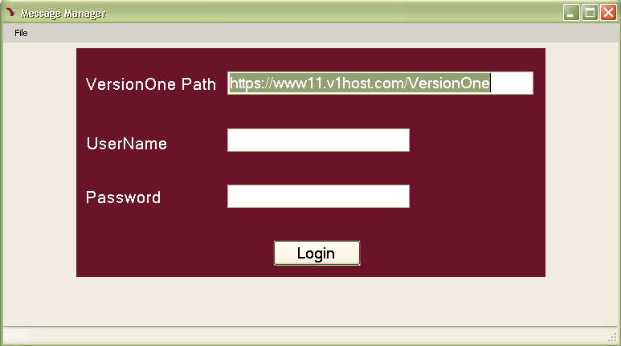

1. After logging in, click “LoadMessages” to get all of the messages that belongs to you.

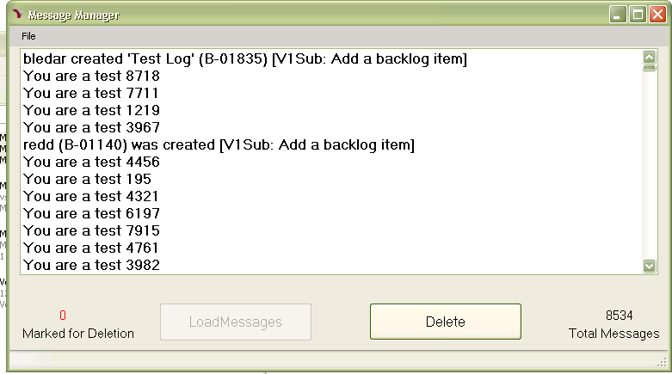

1. Deleting is very slow for this release so consider that it might take .75-1 second per delete. If you had 10000 messages, this could take more than 2 hours to delete depending on busy your VersionOne server is. Here are two ways to delete your messages
   1. Delete All – If you don’t mind letting this app work busily on your machine while attempting to do something else,
      1. Press Ctrl-A to select all of your messages. The marked for deletion count will reflect all of your messages being selected.
      2. Click “Delete” and wait.
   2. Incremental Deletion – Use windows shortcuts to select 1 or more or pages of notifications to delete. My favorate way to delete is to
      1. Click the first Notification
      2. Press “Page Down” to select a page of items to delete at a time. This way you don’t slow down your server and possibly slow down your PC

Please send your questions or comments to [support@VersionOne.com](mailto:support@VersionOne.com)